LAB 02: Buffer Overflow Attack (Ubuntu 20.04 VM)
Name: S M AHSANUL KABIR

Task 1: Demonstration of launching a shell program from execve() and shellcode placed on stack

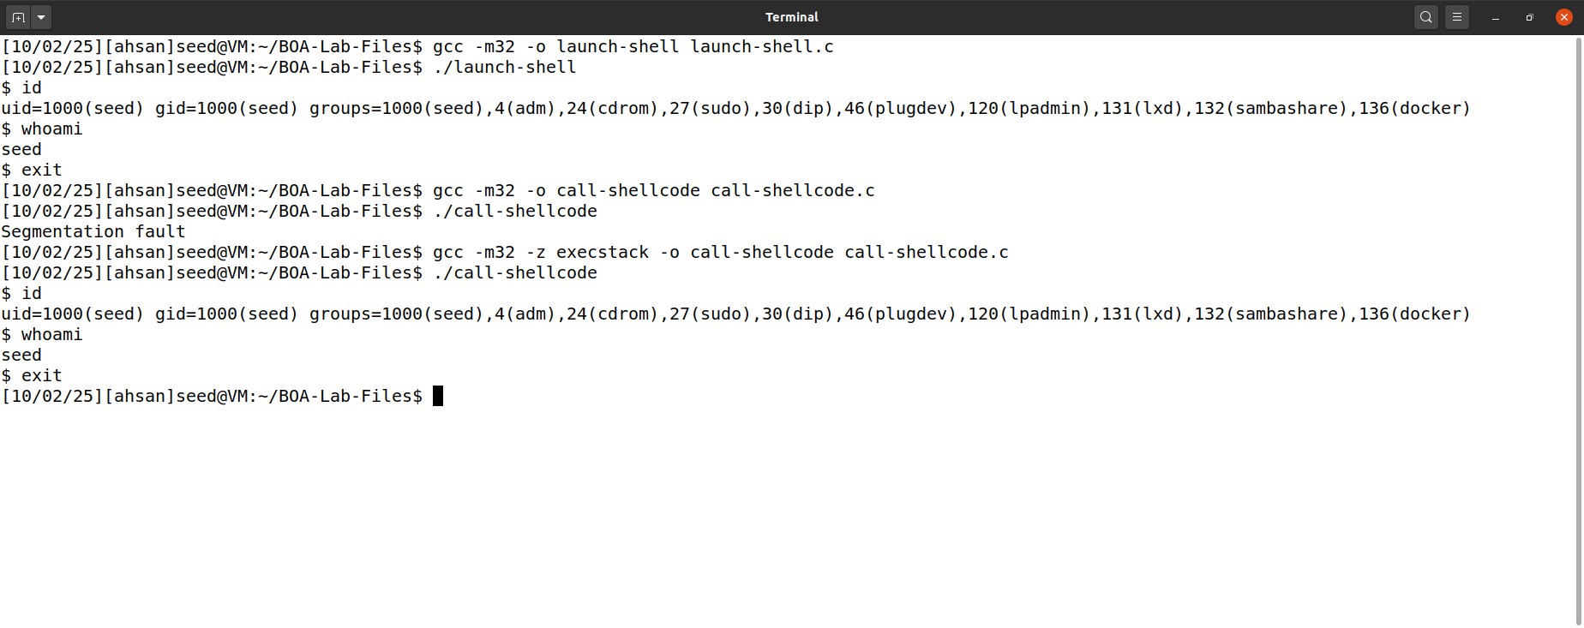

Task 2: Buffer Overflow Attack
